

Project Report: Bookistan Website Development
Project Title: Bookistan – A Digital Haven for
Curious Minds
Course Name: Application of Information and Communication Technologies
Course Instructor: Ms. Ramsha Khalid
Semester: First Fall 2025
Date: 12/25/2025

Group Members
Maheen Mohsin 2025-GA-33

Alishwa Rizwan 2025-GA-20

Abdul Ahad 2025-GA-03

Abdul Rafay 2025-GA-02

Asad Hussain 2025-GA-57

1. Executive Summary | 3
2. Project Objectives & Scope | 3
3. Site Structure & Navigation | 4-7
4. Design Choices | 7
5. Assets Used | 8
6. How to Run/Publish the Site | 8
7. Reflection | 8
Table of Content

1. Executive Summary
Bookistan is a modern, aesthetically pleasing online bookstore designed to provide a tranquil digital environment for bibliophiles. The platform serves as a "Place for Curious Minds," moving beyond a simple retail site to create a community space where readers can explore trending titles, discover new authors, and engage with literary blog content. By utilizing a cohesive earth-tone color palette and user-centric navigation, the project achieves a professional and welcoming interface.

2. Project Objectives & Scope
Objectives: To design a functional web interface that effectively showcases books and authors while maintaining a high standard of visual design.

Scope: The project encompasses a comprehensive Home page, a categorized Book gallery, an "About Us" mission statement, a dedicated Blog section for articles, and a location-based "Visit Us" page with integrated mapping.
3. Site Structure & Navigation
The website is organized into five primary sections to ensure a seamless user journey:

🏠 Home Page: Acts as the primary landing zone that introduces the brand identity and the core mission statement to visitors.
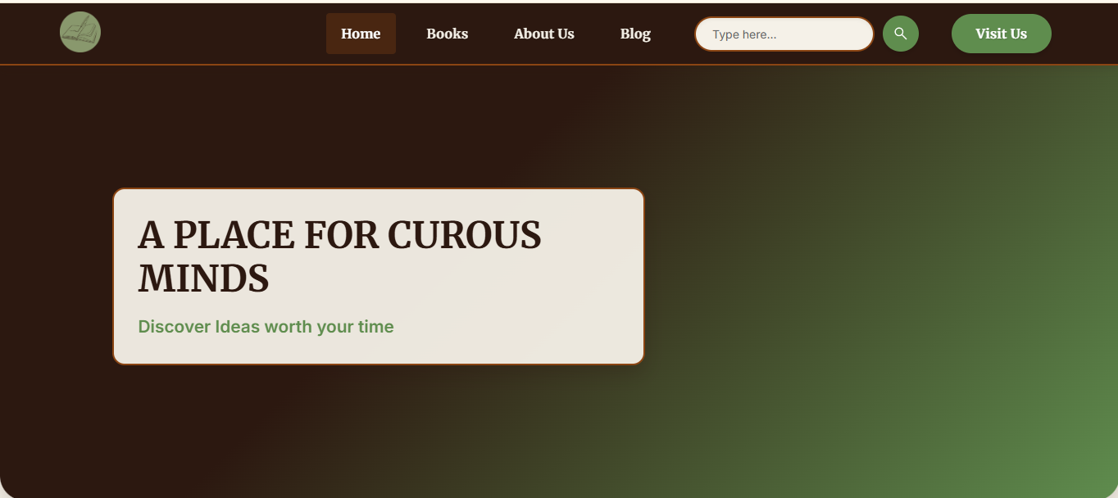

📚 Books Gallery: Designed for easy browsing, this section displays "Trending Books" and separates titles into searchable categories like "Action" and "Fantasy".

Summary Statistics:
  - Total Sales: 20,541
  - Average Sales: ~662.61
  - Number of Books with Sales > 500: 24
  - Genre-wise Sales:
    - Fantasy: 5,095
    - Romance: 3,906
    - Mystery: 3,790
    - Horror: 3,489
    - Sci-Fi: 2,191
    - Educational: 2,070

Data Integration & Insights
- Total books in inventory: 31
- Total sales across all genres: 20,541 units
- Fantasy was the highest-performing genre, contributing 5,095 sales.
- A significant majority of titles (24 out of 31) surpassed the 500-sales mark.
This data informed our choice to highlight high-performing books like 'Beneath the Shadows' (995 sales) and 'The Silver Key' (946 sales) in the 'Trending Books' section of the gallery."

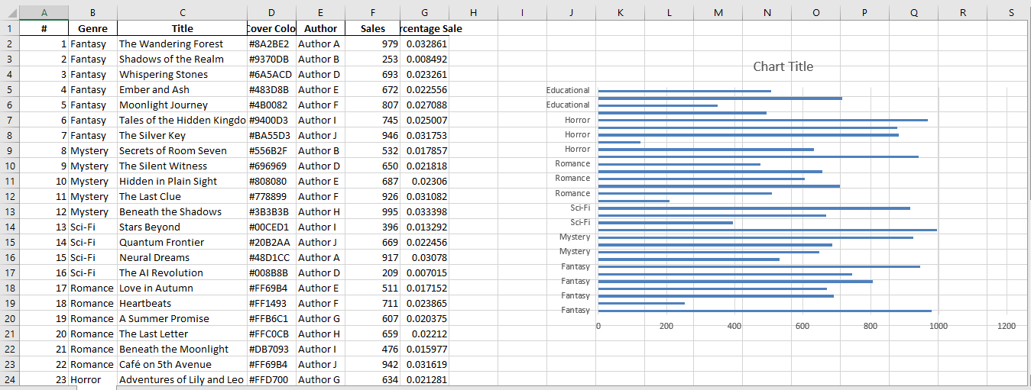

Trending Books

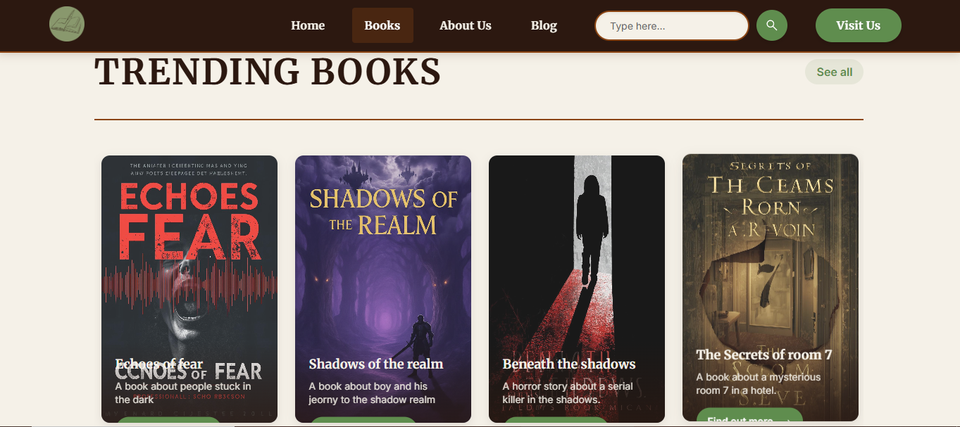

Categories

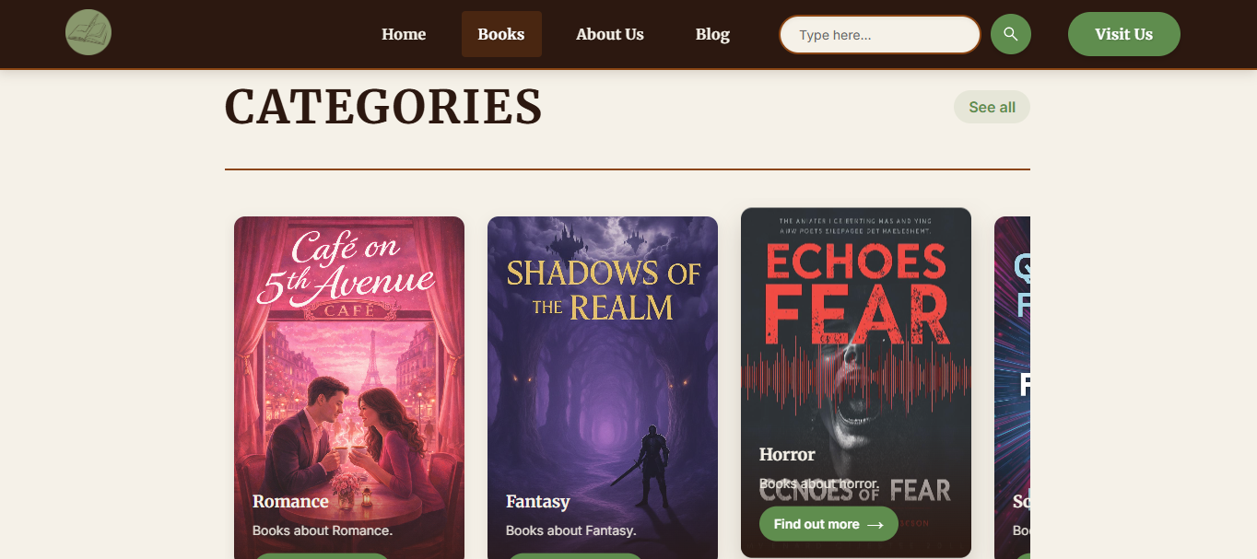

📖 About Us: Provides a narrative backstory of the brand, emphasizing its commitment to being a "welcoming space for readers of all kinds".

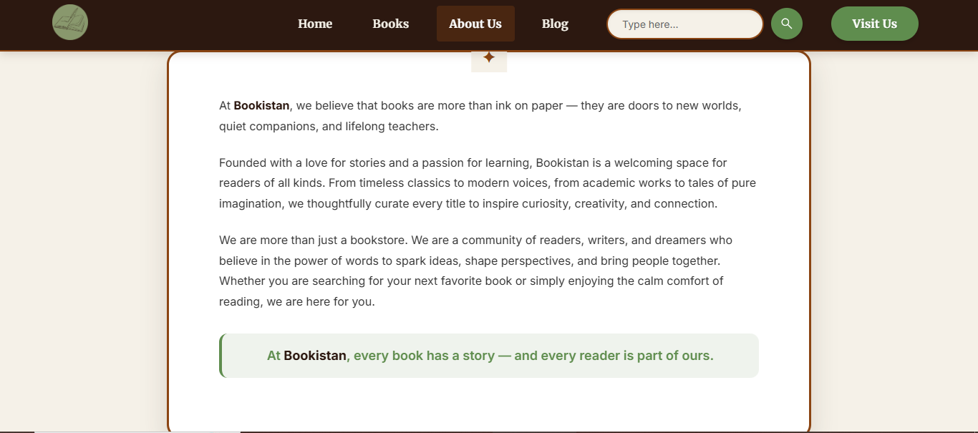

✍️ Blog Section: Enhances user engagement by featuring curated articles like "The Magic of Reading" and "Why Bookstores Still Matter".

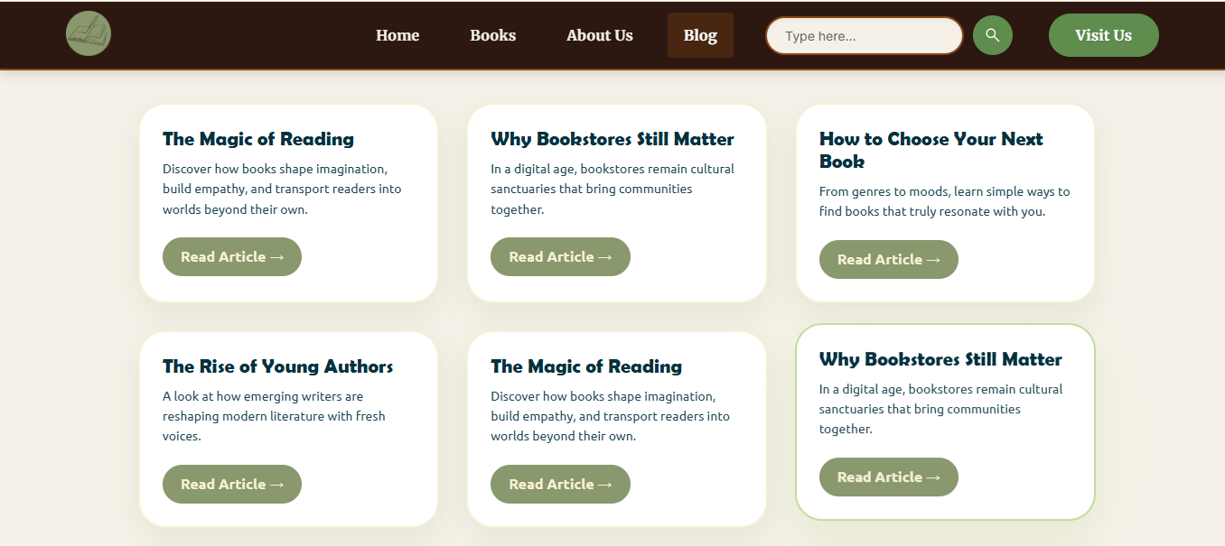

📍 Visit Us: Offers essential contact information and a visual Google Map showing the store’s exact proximity to UET Lahore.

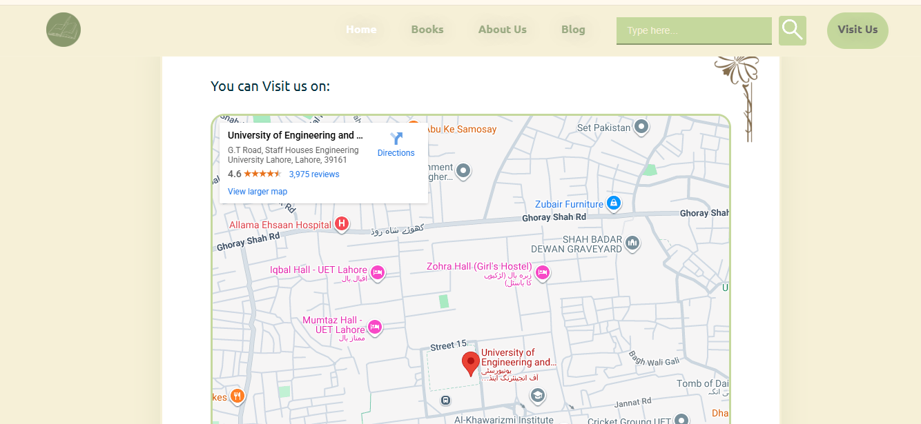

4. Design Choices
- Typography: The site uses a mix of bold, stylized headings for section titles (e.g., "Authors", "Trending Books") to create strong visual hierarchy, paired with clean, readable sans-serif fonts for body text.

- Color Palette: A sophisticated "Earth-Tone" scheme was chosen, featuring a Light Beige background to reduce eye strain and Sage Green accents for buttons and search bars to evoke a sense of calm and nature.

- Layout Decisions: A card-based design is used for the Author and Blog sections, providing a structured and organized look that is easily adaptable for mobile responsiveness.

5. Assets Used
- Imagery: High-resolution library shelf backgrounds are used for headers to establish a "bookish" atmosphere immediately.

- Graphics: Custom circular author avatars and book cover art are utilized to give the site a unique and friendly character.

- Data Sources: Integration of the Google Maps API for the "Visit Us" section to provide real-time location data.

6. How to Run/Publish the Site
Local Access: Open the project folder and double-click the index.html file to launch the site in any modern web browser (Chrome, Firefox, or Edge).

Navigation: Users can navigate between pages using the top menu bar or the "Visit Us" button in the header.

Publishing: For public access, the source code can be hosted on platforms such as GitHub Pages, Netlify, or Vercel by uploading the root directory.

7. Reflection
Learning Outcomes: Developing Bookistan provided deep insights into UI/UX principles, specifically how a unified color scheme and consistent spacing can improve the user experience.

Future Improvements: Future iterations could include a functional e-commerce shopping cart, a user review system for books, and a live search filter to help users find specific titles instantly.

8. Project Connectivity & Assets
- Live URL: bookstore_website

